RAMON (CHSA) BRAND LABEL

Ramon Product Code: KPY12

Stock/sales unit: per case of 50

Description: Size 12PY Kentucky Mop

Made in Pakistan

Mop Length: 76cm (Length may vary slightly to accommodate fluctuation in yarn count and maintain weight specification).

Mop Weight: 341g +/-3%

Yarn: 3 fold 0.85’s English Cotton Count
Minimum 80% cotton with 20% mixed fibres
Colour: ecru

Number of Ends: 108 (Number of ends may vary slightly to accommodate fluctuation in yarn count and maintain weight specification).

Centre Tape: 31mm wide
Printed with mop size and CHSA logo
100% cotton. Colour: ecru

Sewing:
Stitching: Nylon thread

Colour Coding:
Colour coded Kentucky mops have 7.7cm of 13mm wide satin tape sewn into the centre band of the mop. The 4 colours of tape are: blue, green, red and yellow and are sewn in at one end only.

Labelling:
Transit bar code: 5011251 016165

Packaging:

All packaging is recyclable and meets with the Packaging (Essential Requirements) Regulations 2003.
Details for Producer Responsibility Obligations (Packaging Waste) Regulations 2007 are as follows:-

Primary Packaging: Single mop per plain polythene bag
(Size: 470 x 200mm – weight: 6.5g)

Transit Packaging: 50 mops per cardboard carton
(Size: 500 x 400 x 460mm - weight: 1240g)
Gross weight: 18.6kg

Palletisation: 18 cases per standard 4-way pallet

(3 layers of 6 cases)
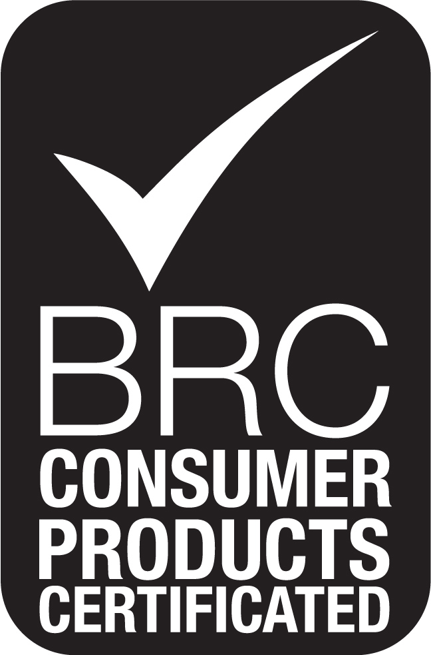
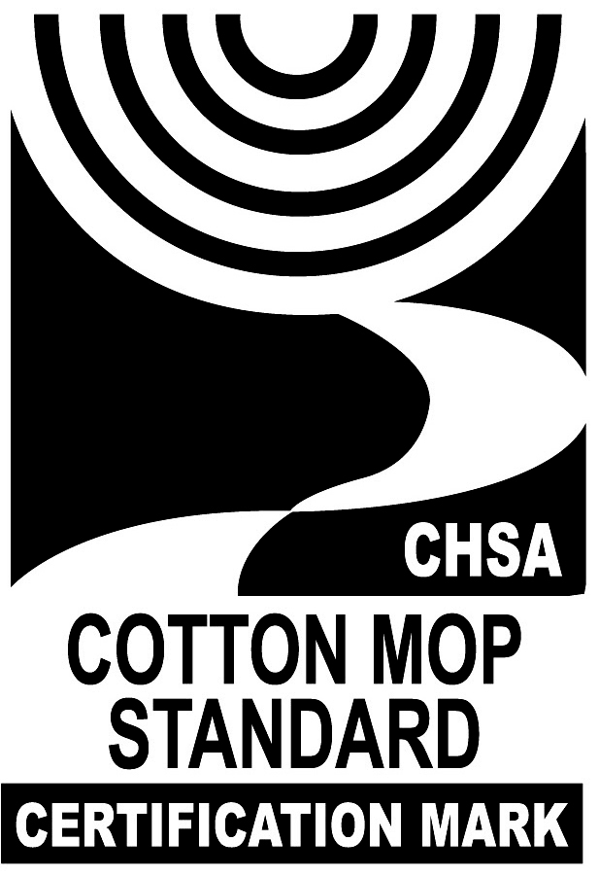
Overall pallet height: 1.53m

